Distinct functional responses of producers and their consumers to climate shape trophic asymmetry in mutualistic networks

Gabriel Munoz

Paul Savary

W. Daniel Kissling

Jean Philippe Lessard

2025-04-05

Abstract

Functional traits are often used to infer the ecological processes that determine the composition of species assemblages. Whereas most trait-based approaches to infer community assembly processes focus on a single trophic level, traits also mediate interactions between trophic levels. Owing to the matching of traits facilitating interactions between producer and consumer assemblages, the functional trait diversity of different trophic levels is expected to covary in space. However, the differential response of consumers and producers to environmental gradients can cause a decoupling of functional diversity between trophic levels, which we coin functional trophic asymmetry. Here, we develop a metric to quantify functional trophic asymmetry (FTA) and use it to infer the processes underpinning multitrophic community assembly and explore the role of these processes in shaping the topology of ecological networks.

We used digitally available data on the functional traits, pairwise mutualistic interactions, and geographic distributions of consumers (mammalian frugivores) and their producers (palms) to quantify FTA for species assemblages occurring in the Neotropics. To cover major data gaps between species-level trait and interaction data at finer spatial grain, we trained machine learning models to downscale the continental meta-network to grid cell-level networks. For each grid-cell, we also estimated FTA for all combinations of interaction guilds. These guilds were defined as distinct subsets of producer and consumer assemblages playing similar roles within mutualistic networks and sharing partners in the other trophic level. We then used generalized additive models to relate geographic variation in FTA to variation in climatic variables and assessed whether the strength of these relationship varied among pairwise interaction guilds. Finally, we then examined the relationship between FTA and network specialization across 1,072 grid cells in the Neotropics.

Our approach to model mutualistic network assembly identified 7 consumers x producer interaction guilds. Assemblage-wide FTA was negatively related to annual mean temperatures across the neotropics. When considering individual interaction guilds, precipitation seasonality was positively related to FTA. This relationship between FTA and precipitation seasonality was stronger for consumer and producer guild combinations with high predicted interaction strength. Finally, network specialization was positively related to FTA, regardless of the interaction guild combination.

Mutualistic networks in warm regions with seasonal rainfall, where the environment imposes a disproportionately strong selective pressure on palms relative to mammal frugivores, exhibit higher levels of functional trophic asymmetry. This relationship is particularly strong when considering guilds predicted to strongly interact in nature. Assemblages exhibiting high FTA also tend to have high levels of network specialization, suggesting that differences in the strength of environmental selection among trophic levels favor the persistence of specialist species in these mutualistic interaction networks. We therefore conclude that future increases in temperature and the magnitude of precipitation seasonality caused by global climate change could lead to more specialized mutualistic networks which are more prone to collapse when facing further threats and local extinctions.

## 1 Introduction

Ecologists often examine patterns of functional trait diversity to investigate community assembly processes (Ackerly 2003; Kraft et al. 2015). To date, however, trait-based approaches in ecology often focus on a single trophic level, whereas approaches that consider multiple trophic levels remain rare (Lavorel 2013; Seibold et al. 2018). An approach that considers processes operating within and between trophic levels is necessary to better understand the assembly of multitrophic communities (Allesina, Alonso, and Pascual 2008; Marjakangas et al. 2022; Saravia et al. 2022). Moreover, considering trophic interactions while studying community assembly could shed new light on processes underpinning ecological networks (Allesina, Alonso, and Pascual 2008). Classical approaches to study community assembly rely on the concept of environmental filtering, sorting or selection, where density independent conditions constrain the functional richness of species assemblages (Laliberté and Legendre 2010; Villéger, Mason, and Mouillot 2008; HilleRisLambers et al. 2012; Kraft et al. 2015). Functional richness refers to the variability and relative frequency of different functional traits observed in a community. It is often used to estimate the strength of selection imposed by the environment (Kraft et al. 2015; Kraft and Ackerly 2010; Kraft, Valencia, and Ackerly 2008). High functional richness can indicate weak environmental selection whereas low functional richness can indicate strong selection (Kraft, Valencia, and Ackerly 2008; Halpern and Floeter 2008; Paine et al. 2011). In a multitrophic context, the effects of environmental selection can cascade across trophic levels such that selection on consumer traits can shape the functional richness of their resources, modulated by their degree of reciprocal dependency or co-evolution (Lavorel 2013). Moreover, the same environmental gradient could exert selective pressures of different strength on communities at distinct trophic levels (Marjakangas et al. 2022). Differences in the strength of selective pressure among trophic levels could then possibly constrain the structure or topologies of trophic networks (Blüthgen et al. 2007; Schleuning et al. 2012; Dehling et al. 2021)

Inferring the relative strength of environmental selection between trophic levels requires using high-dimensional approaches that can deal with sparse observations for many species (Rohr et al. 2010; Strydom et al. 2022). We introduce the concept of functional trophic asymmetry (FTA), which allows inferring the relative influence of environmental selection and trait matching on the composition of multitrophic assemblages (Figure 1). FTA is the difference in the richness of interaction-relevant traits between trophic levels in a multitrophic network. FTA can occur because traits mediating species interactions (i.e., interaction niches) across trophic levels can also mediate the responses of species to their abiotic environment (i.e., environmental niches) (McCain and King 2014; Moretti and Legg 2009; Dehling et al. 2021). As an example, plant seed size determines the outcome of animal-mediated seed dispersal (Donoso et al. 2017, 2020) as well as physiological limits, such as tolerances of plant seedlings to desiccation (Hoekstra, Golovina, and Buitink 2001). High FTA could indicate differences in the strength of environmental selection over the interaction niches of distinct trophic levels within a multitrophic species assemblage. Alternatively, low FTA could indicate that the strength of the environment selection shaping interaction niches is similar between trophic levels, e.g., equally weak or equally strong (Marjakangas et al. 2022). When interactions between producers and consumers are mutualistic, low FTA could also emerge under strong trait matching and therefore indicate the influence of trait co-evolution during multitrophic community assembly (Dehling et al. 2021; Albrecht et al. 2018). By studying spatial variation in FTA along environmental gradients, we could possibly identify the conditions promoting environmentally versus cross-trophic interaction- driven community assembly (Bello, Schleuning, and Graham 2023).

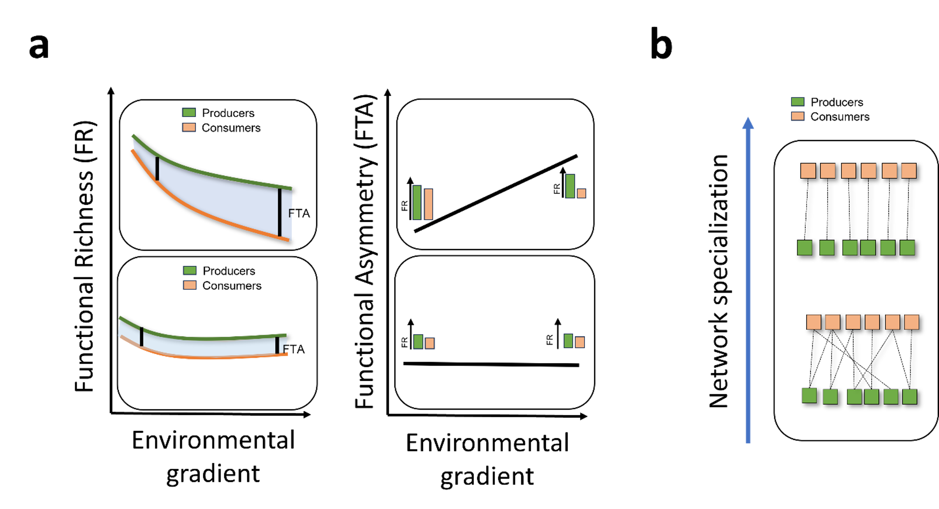

This conceptual model illustrates the dynamic relationship between functional diversity metrics—specifically Functional Richness (FR) and Functional Trait Asymmetry (FTA)—and environmental gradients within ecological networks. The left panel of Figure a) visualizes the variation in FR for producers (depicted in green) and consumers (depicted in orange) along an environmental gradient. As the environmental gradient intensifies (e.g., through changes in temperature, precipitation, or habitat fragmentation), FR for both producers and consumers generally decline. However, this decline can occur at different rates, leading to two scenarios: (1) Differential Decline in FR: If consumer FR declines more sharply than producer FR, a substantial increase in Functional Trait Asymmetry (FTA) occurs. (2) Parallel Decline in FR: Alternatively, if both producer and consumer FRs decline at a similar rate, FTA remains relatively constant along the gradient. This scenario indicates a balanced impact of environmental changes across trophic levels, preserving the relative functional relationship between producers and consumers. Figure b) shifts focus to the implications of changing FTA on network specialization—a measure of how distinct generalized interactions are between producers and consumers within ecological networks.

Frameworks linking multitrophic functional diversity to network topology along broad-scale environmental gradients are crucial to understand the effects of global change on biodiversity and ecosystem function (Bello, Schleuning, and Graham 2023; Dehling et al. 2021; Schleuning et al. 2012). Functional responses of consumer and producer assemblages to climate influence functional richness at the level of the multitrophic community (Garcı́a, Donoso, and Rodrı́guez-Pérez 2018). Because some of these traits are involved in interactions across trophic levels, the filtering of traits along environmental gradients could constrain the identity, number, and frequency of species interactions and therefore, network topology (Marjakangas et al. 2022; Emer and Memmott 2023; Albrecht et al. 2018). As an example, constraints of varying intensities along climatic gradients, which limit the relative availability of interaction partners across trophic levels, could influence emergent patterns in network structure such as the specialization of multispecies interactions (Blüthgen, Menzel, and Blüthgen 2006; Blüthgen et al. 2007; Marjakangas et al. 2022). While high levels of network specialization represent networks predominantly made of “one-to-one” interactions, low levels of network specialization represent networks with species showing predominantly “one-to-many” interactions (Blüthgen, Menzel, and Blüthgen 2006; Blüthgen and Klein 2011) (Figure 1B). One highly expected outcome is that when functional trophic asymmetry is high, networks will have low specialization. For example, take a plant community exhibiting a low richness of flower displays and which is associated with a bee community (pollinators) exhibiting a wide variety of proboscis lengths. These plants are unlikely to form “one-to-one” interactions with only a subset of bee species that have matching proboscis length. Otherwise, non-matching pollinators would have no food resources and be extirpated. By partitioning deviations from expected FTA and network specialization relationships with null models, one can separate the relative influences of processes operating between trophic levels (e.g. trait matching) and those within trophic levels (e.g. environmental selection) in network assembly (Marjakangas et al. 2022). However, the relationship between network specialization and functional trophic asymmetry has not been fully explored.

Preserving mutualistic interactions between palms and their mammalian frugivores is important to sustain biodiversity and ecosystem function in the tropics (Bogoni, Peres, and Ferraz 2020; Marques Dracxler and Kissling 2022). Mammalian frugivores facilitate the dispersal of palm fruits, which helps to prevent local extinctions amid disturbance and to maintain biodiversity in these ecological networks (Acevedo-Quintero, Zamora-Abrego, and Garcı́a 2020; Messeder et al. 2021; Dehling, Barreto, and Graham 2022). To effectively preserve these interactions, it is crucial to understand how co-occurring palm (producer) and mammalian frugivore (consumer) communities respond to environmental gradients. By examining co-variation in their functional richness across broad geographic scales and linking those patterns to spatial and/or temporal variation in climate, we can identify key abiotic factors that influence the assembly of their mutualistic relationships. Here, we ask (1) *which climatic variable(s) best explains geographic variation in the functional richness of palms and mammal frugivores*, (2) *whether differences in these relationships lead to functional trophic asymmetry (hereafter FTA)*, and (3) *which climatic variable best explains geographic variation in FTA across the Neotropics*. We also ask (4) *whether the strength of interactions between palm-frugivore interaction guilds relates to the strength of the relationship between FTA and climate*. Finally, we ask (5) *whether geographic variation in FTA relates to network specialization*.

## 2 Methods

### 2.1 Study system

We focused on multitrophic communities of Neotropical palms and their mutualistic, seed dispersing, mammalian frugivores (Figure S1). Palms (Plantae:Arecaceae) are a keystone plant family in tropical regions that provides fruit resources to a wide variety of vertebrate frugivores, including birds and mammals (Muñoz, Trøjelsgaard, and Kissling 2019). Frugivore mammals (Animalia:Mammalia) are among the most important palm-seed dispersers, particularly over long distances. Most frugivore mammals feeding on palms are seed eaters and pulp eaters, dispersing palm seeds mostly via ectozoochorus dispersal (Messeder et al. 2021). Importantly, frugivory-related traits have notably underlain palm diversification and played a key role in the evolution of palm traits (Kissling et al. 2012; Onstein et al. 2014, 2017).

### 2.2 Data sources

#### 2.2.1 Geographic distribution data

We obtained binary species distribution data (present/absent) on palms from the geographic range maps of (Bjorholm et al. 2005) and on mammals from the IUCN (International Union for the Conservation of Nature) data portal. To generate local gridded multitrophic species assemblages across the Neotropics, we intersected the species-level range maps with a spatial grid where each grid cell represented every 1 by 1 degree latitude and longitude change along the extent of the entire Neotropics. We then listed all palm and mammal frugivore species co-occurring in each grid-cell as our grid-cell level multitrophic assemblage.

#### 2.2.2 Trait data

We collected species-level multitrophic trait data related to the physiological tolerance of palms and frugivorous mammals to the abiotic environment and to their mutualistic interactions. For palms, we extracted data from the PalmTraits 1.0 dataset (Kissling et al. 2019). We collected data on growth form, maximum stem height, and average fruit length. For frugivorous mammals, we obtained trait data from the EltonTraits 1.0 database (Wilman et al. 2014). We selected data on body mass, diet, and daily activities. Diet data from the EltonTraits 1.0 database is coded as percentage use distribution across ten diet categories. We excluded from our analysis species without fruit in their diet. Activity was coded as a dummy variable with three categories (Diurnal, Crepuscular, Nocturnal). Finally, body mass was coded as a numerical variable in kg. We excluded bats from the analysis as almost no Neotropical bat species is feeding on palm fruits (Messeder et al. 2021). From this dataset, we selected only those species whose range in gridded multitrophic communities within a regular 1×1° latitude grid co-occur with at least 5 other palm and mammal frugivore species in the same grid. In total, we worked with a subset from this dataset of 494 palm species and 488 mammal frugivore species with linked trait and geographic data. Pairwise interaction data

We used data on seed dispersal interactions between palms and mammals for the Neotropics, originating from recollections of seed dispersal records found in the published literature and interaction records are recorded at the species level (Muñoz, Trøjelsgaard, and Kissling 2019). Each pairwise species interaction record reflects where an article mentions the fruit or the seed of a palm being dispersed, carried or defecated by a frugivorous mammal. Interaction records collected in this database were previously vetted to reflect effective seed dispersal interactions, while avoiding those that reflect mere seed consumption (vetting criteria found in: Muñoz, Trøjelsgaard, and Kissling (2019) ). In total, we gathered a total of 581 interaction records between 69 palms and 111 frugivore mammals.

#### 2.2.3 Environmental data

We used bioclimatic variables from WorldClim (Fick and Hijmans 2017) to represent large-scale spatial and temporal variation of climate in the Neotropics. Specifically, we used mean annual temperature (BIO01), total annual precipitation (BIO12), temperature seasonality (BIO04) and precipitation seasonality (BIO15). Using a moving window, we compute simple averages for every set of bioclimatic records at each grid cell, thereby re-scaling the spatial resolution of bioclimatic variables to 1 by 1 degree grid resolution from their original resolution (1 x 1 km2) to match the spatial resolution of our grid cell species-level data (Figure 2)

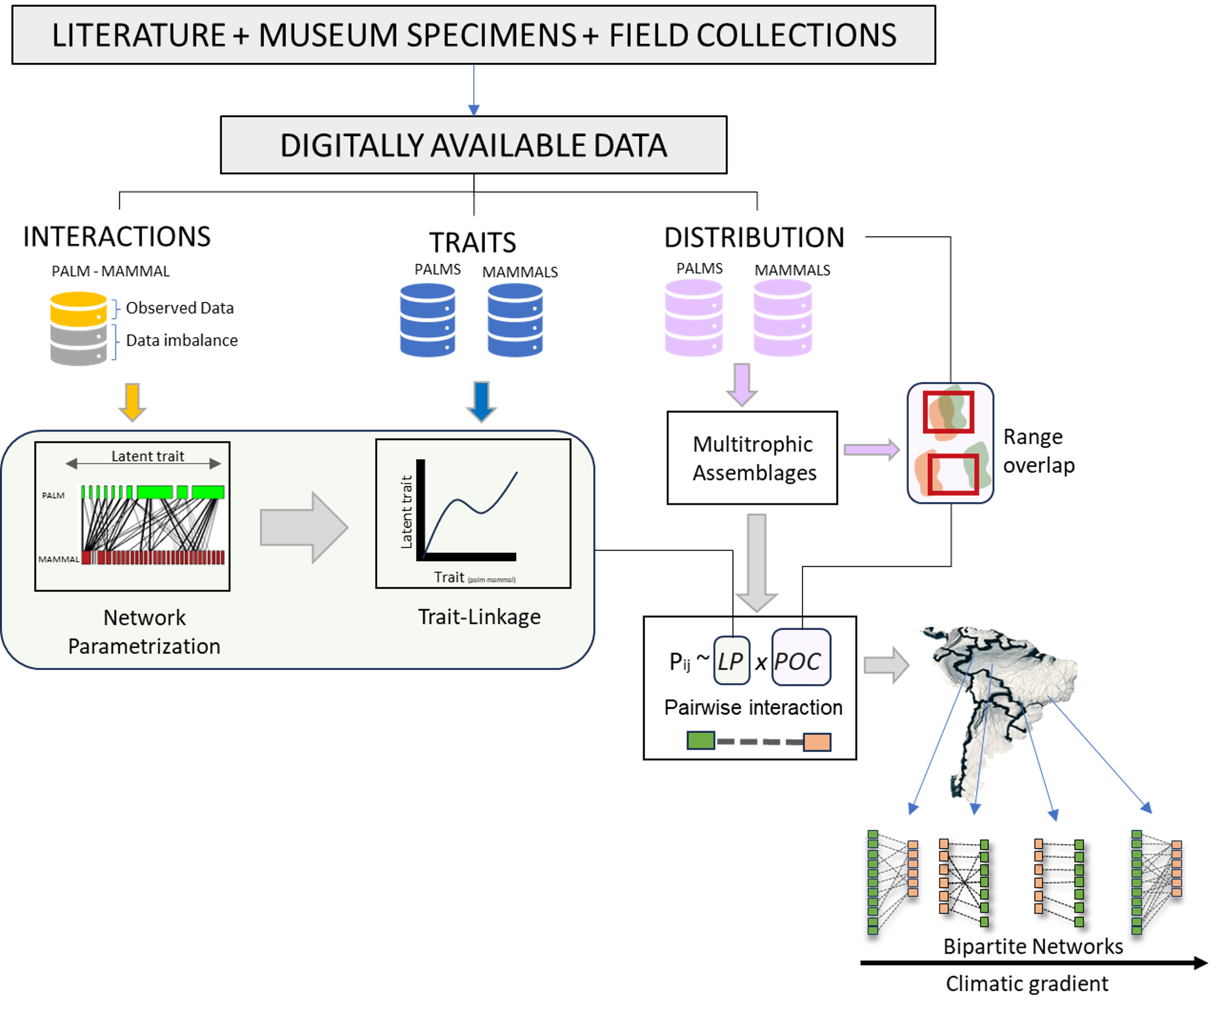

Workflow illustrating the integration of ecological and trait data from digital sources to model species interactions and predict ecological networks across geographic regions. The figure illustrates a workflow for integrating ecological interaction data derived from literature, museum specimens, and field collections into digitally available datasets. These datasets are used to build ecological network models and link species interactions to their biological traits. The approach involves parameterizing networks based on latent traits and identifying trait-linkages, which are subsequently utilized to predict ecological interactions and networks across different geographic locations (e.g. The Neotropics)

### 2.3 Statistical analysis

Building a probabilistic continental metaweb from aggregated binary interaction records Here, we fitted latent variable network structural models that vary in their assumptions to estimate interaction probabilities from observed binary data on species interactions. (Figure 3) Specifically, we tested: the stochastic block model (SBM), the connectance model, the trait-matching model, and the matching-centrality model (Terry and Lewis 2020). The SBM assumes that ecological networks are modular, with species of consumers interacting more within their preferred groups of producers (i.e., interaction guilds). This model outputs three incidence matrices, reflecting predicted interactions: (i) one with guilds of palm species based on their modular interactions with mammals, (ii) a similar one for mammals, and (iii) one representing the interaction probabilities (Theta) among the guilds of each group (i.e., palm guilds-mammal-guild). The connectance model posits that interactions of specialist species are subsets of those of generalist species, optimizing connectivity scores to recreate observed network patterns. The trait-matching model assumes non-random species interactions determined by trait differences, optimizing parameters along latent-trait axes. The matching-centrality model combines connectivity scores and latent-trait axes (Terry and Lewis 2020). We fitted these models to our available interaction data and selected the model that best predicted the observed continental pattern of seed dispersal interactions. Using Youden’s J as a metric that balanced model sensitivity and specificity (Poisot 2023), we found that the SBM was the best supported model (Figure 3) and therefore focused on it in the rest of the manuscript. Additional details about the model assumptions are explained in Supplementary Text S1.

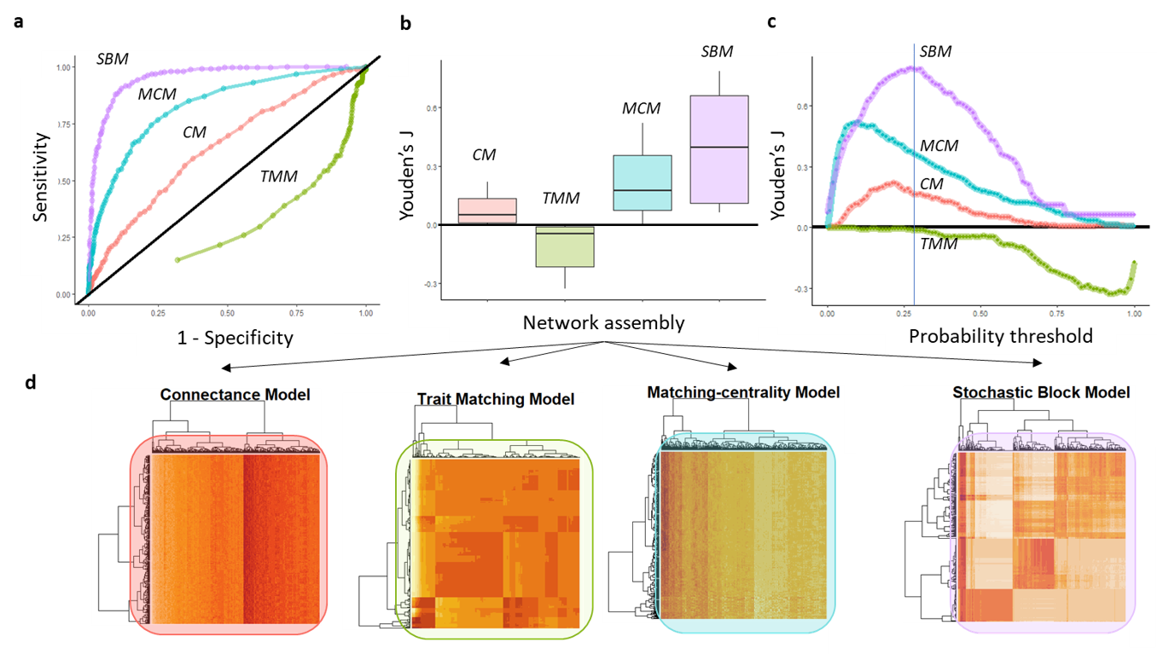

Model evaluation plots of distinct structural models fitted to predict the structure of the observed palm-mammal frugivore interactions in the Neotropics. In this figure we illustrate a comparison of ecological network assembly models using ROC curves (a), Youden’s J index (b,c), and clustering heatmaps (d) to illustrate differences in predicting species interactions. Specifically, the figure compares four ecological network assembly models—Centrality Model (CM), Trait Matching Model (TMM), Matching Centrality Model (MCM), and Stochastic Block Model (SBM)—in their ability to accurately predict a observed binary pattern of species interactions. For our study, this observed pattern reflected the incidence of seed dispersal interactions between palms and their mammalian frugivores. The ROC curves (a) indicate model performance in terms of model sensitivity (i.e. true positive rate) versus model specificity (true negative rate). Curves further above the diagonal demonstrate stronger predictive ability, showing that the model performs significantly better than random guessing in identifying ecological interactions. If a ROC curve is close to or below this diagonal, the model’s predictive performance is no better than random chance. The central boxplot summarizes the Youden’s J index, where higher values reflect higher overall predictive accuracy. Panel (c) shows Youden’s J index variation over different probability thresholds to materialize binary interactions. The heatmaps below visualize clustering patterns, highlighting structural differences in predicted interaction networks for each model.

#### 2.3.1 Identifying interaction guilds

Since the hyperparameters of the Stochastic Block Model (SBM) provided the best fit for capturing the observed interactions, palm-frugivore interaction networks are highly modular and certain groups of producers are more likely to interact with certain groups of consumers than others, and vice versa. In this context, we define an interaction guild as a distinct group of palm and mammal species within the continental metaweb that exhibits similar interaction patterns. Within each guild, both producer and resource species perform comparable functional roles in the network. Within and between each guild combination of consumers and producers, species pairs exhibit the same interaction strength, where interaction strength is defined as the magnitude or intensity of the effect that one species has on another within an ecological network. Here we estimate interaction strength as the probability that a species pair would interact in nature. The SBM estimates such interaction probabilities based on the frequency of interactions observed between species assigned to given guild of consumer or producer. The SBM model uses maximum likelihood to adjust the number of guilds and the distribution of interaction probabilities within and between guilds such that they best explain the observed pattern of interactions. Using SBMs largely reduces the complexity of dealing with interaction strengths by treating them as a guild-level phenomenon instead of a species-specific one.

#### 2.3.2 Downscaling the continental metaweb to generate grid-cell level networks

The digital availability of primary biodiversity data on palms and their mammalian frugivores was imbalanced, with a high availability of distribution ranges and species traits, but a limited number of interaction records. Therefore, to downscale our initial metaweb to include interactions between every potentially co-occurring palm and mammal frugivore in every grid cell across the Neotropics, we used a twofold approach (Figure 2).

First, we employed multinomial logistic regression models to predict the species level SBM model results (i.e., interaction guild affiliation) from species-level trait data. We justify the choice of multinomial logistic regression models as these can handle the prediction of non-binary outcomes, such as the labeling of interaction guilds per species. We fitted separate multinomial models for palms and mammal frugivores using a label backpropagation algorithm and a neural network engine, with 75% of the data allocated for training and the 25% remaining for testing. We use neural networks because they are useful when dealing with multicollinearity, as they can learn complex and non-linear relationships and interactions among multiple predictor variables. This allowed us to separate the relative importance of distinct matching traits on SBM group affiliations. We extracted variable importance scores based on the combinations of the absolute values of the best fit model weights (Gevrey, Dimopoulos, and Lek 2003)

Second, we considered local pairwise species interaction probabilities as the product of the values from the Theta matrix from the SBM model that represent the latent interaction probabilities between species pairs within and between groups multiplied by their probability of co-occurrence (POC) in a grid cell. To represent species’ co-occurrence probabilities, we used the reciprocal distance between the centroids of species pair ranges within the grid-cell, divided by the sum of their range areas within the grid-cell. This implied that within each grid cell, species with closer range centroids and larger cumulative areas are more likely to co-occur and interact. This approach allowed us to recreate synthetic probabilistic plant-mammal frugivore networks for each grid-cell across the Neotropics, while accounting for the heterogeneity of species ranges within each grid.

#### 2.3.3 Estimating Functional Richness

We investigated the spatial variation in the relative distribution of species counts of producers and consumers across all guilds in a grid cell, as an interaction network-level indicator of the spatial distribution of producer and consumer species’ functional richness. We estimated functional richness (FR) from the results of the SBM model fit, specifically, from the matrices representing the interaction guilds. Thus, to measure functional richness for each trophic level, we calculated a grid-cell level vector representing the number of species across all interaction guilds (n = 7). To account for the differences in the total number of palm and mammal species across grid cells, we normalized this vector to the total sum of palm or mammal species counts within each grid cell.

#### 2.3.4 Estimating Functional Trophic Asymmetry (FTA)

We quantified functional trophic asymmetry (FTA) as the absolute difference between the functional richness vectors across trophic levels. Since each palm and mammal species in every grid cell had the potential to be affiliated with any of the seven interaction guilds and to interact with any species from the opposite trophic level both within and between guilds, we derived one FTA measures for each grid cell, and for each pairwise palm-mammal guild combination.

#### 2.3.5 Estimating Network Specialization (H2’)

We estimated network specialization for each grid cell using the metric H2’. H2’ is a network-level index that varies between 0 and 1 (Blüthgen et al. 2007). High values indicate networks that are more specialized, meaning that species from one trophic level interact with only or few species in the opposite trophic level. Low H2’ values indicate that there is a low specificity of interactions in the network, meaning that species from one trophic level interact with multiple species at the other trophic level. Because inferred networks varied in their network size (i.e., number of unique interactions between palms and mammals), we rarefied the computation of H2’ to networks for each grid cell such that they would all have the same size (i.e., number of interactions). Specifically, we rarefied all networks to 100 pairwise interactions and repeated the procedure 999 times to get a distribution of rarefied H2’ values (Terry and Lewis 2020). We then selected the median of this H2’ distribution as our grid cell-level measure of network specialization.

#### 2.3.6 Assessing the influence of climate on FTA

To assess whether climate has an influence on FTA, we fitted a Generalized Additive Model (GAM) to examine the relationships between FTA and four continuous bioclimatic predictors. The GAM approach allows for modelling flexible non-linear relationships between the predictors and the response variable using smoothed functions (Wood 2017). The predictor variables included in our models were Mean annual temperature (Temp), Total annual precipitation (Prec), Temperature seasonality (TS), and Precipitation seasonality (PS). Collectively, are these climatic factors known contemporary factors influencing both the regional and global diversity of plants and mammals (Holt et al. 2018). We fitted separate splines for each of the climatic predictors.

Assessing how interaction strength mediates the influence of climate on FTA To assess whether the strength of interaction between producer and consumer guilds mediate the strength of the relationship between FTA and climate, we included interaction strength as an interaction term in the GAM, allowing splines between FTA and climate to vary non-linearly depending on interaction strength.

#### 2.3.7 Assessing the relationship between FTA and H2’

We used Generalized Additive Model (GAM) to investigate the relationship between rarefied grid cell network level specialization (H2’) as a response variable and FTA (z-scores) as the main predictor. We also added the effect of Mean annual temperature, Total annual precipitation, Precipitation seasonality, and Temperature seasonality as covariate functions because these climate variables may influence H2’ independently of FTA, allowing us to isolate the specific impact of FTA on H2’ while controlling for the indirect effects of climate on FTA. Here, we estimated grid-cell level functional trophic asymmetry (FTA’) by summing the FTA values across all interaction guilds, weighted by their respective interaction strengths. This approach was selected as accounts for the uneven contributions of each guild to network structure, highlighting whether changes in network specialization are primarily driven by shifts in FTA within the more specialized interaction guilds.

## 3 Results

### 3.1 Interaction guild delineation

The Theta matrix derived from the SBM (Stochastic Block Model) analysis (Figure 4) reflects the modular pattern assumed by this model, here identified as the best for frugivore-mammal interactions. Therefore, these interactions are stronger within rather than between guild pairs. Given the associations found with the theta matrix, we can derive that the following high-level trait-trait associations: a) Tall palms with medium-sized fruits can associate strongly with small to medium sized mammals that consume moderate to high amounts of fruit. b) Acaulescent or small-stemmed palms with small to large fruits correlate strongly with either small, moderately frugivorous mammals or small mammals with relatively low frugivory. Finally, c) medium-sized to large sized mammals with moderate to low frugivory levels interact with species with intermediate palm traits (e.g., moderately tall erect palms with medium-sized fruits) (Figure S1).

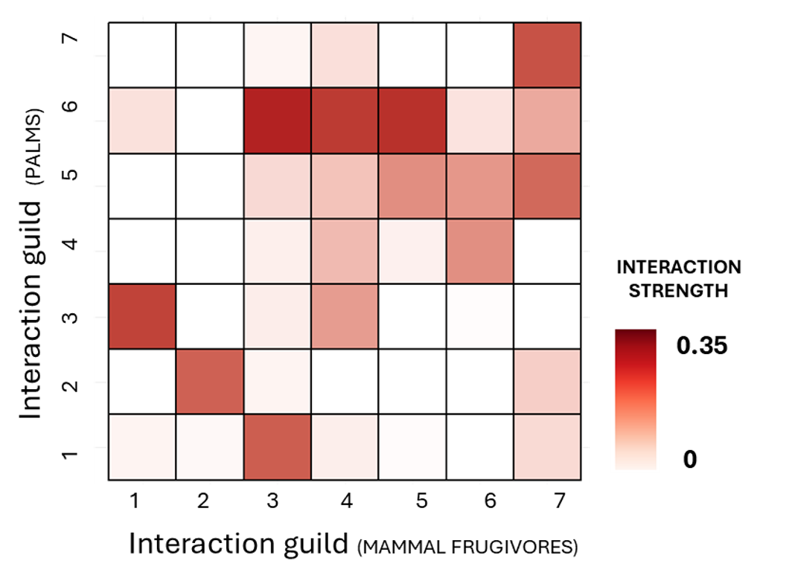

Heatmap depicting the probability of interaction between palm and mammal interaction guilds defined as blocks by the Stochastic Block Model (SBM). The intensity of red shading correlates with the strength of these interactions, where darker shades signify higher probabilities of interaction between species within or between interaction guilds (SBM blocks), where the probability was inferred using the Stochastic Block Model’s estimated interaction parameters (theta Matrix) derived from fitting the model to observed binary (presence = 1, absence = 0) interaction data compiled from scientific literature.

### 3.2 The influence of climate on functional richness

At the grid-cell level, when ignoring interaction guild affiliations, neither the functional richness of palms or mammals relates to geographic variation in climate (Table S1a,b). The functional richness of palms does not relate to temperature (F = 3.00, P < 0.05), precipitation (F = 1.19, P = 0.23), temperature seasonality (F = -0.27, P = 0.79) or precipitation seasonality (F = 0.68, P = 0.50). The functional richness of mammals positively relates to mean annual temperature (F = 10.60, P < 0.05) but not to precipitation (F = 0.001, P = 1.00), temperature seasonality (F = 0.52, P = 0.60) or precipitation seasonality (F = 1.67, P = 0.10). When considering guild affiliation in our analyses, there are marked differences in the relationship between functional richness and climate among trophic levels (Figure 4a,b). The functional richness of palm positively relates to precipitation seasonality for guilds 5 (F = 5.62, P < 0.01) and negatively relates to precipitation seasonality for guild 6 (F = 8.37, P = 0.01). In contrast, the relationship between the functional richness of mammals and precipitation seasonality does not vary among guilds. However, the relationship with temperature does vary among guilds. Specifically, the functional richness of guild 3 positively relates to temperature (F = 11.21, P < 0.01) whereas that of other guilds does not relate to temperature.

|  |  |  |  |  |  |  |  |  |  |  |  |  |  |  |  |  |  |  |  |  |  |  |  |  |  |  |  |  |  |  |  |  |  |  |  |  |  |  |  |  |  |  |  |  |  |  |  |  |  |  |  |  |  |  |  |  |  |  |  |  |
| --- | --- | --- | --- | --- | --- | --- | --- | --- | --- | --- | --- | --- | --- | --- | --- | --- | --- | --- | --- | --- | --- | --- | --- | --- | --- | --- | --- | --- | --- | --- | --- | --- | --- | --- | --- | --- | --- | --- | --- | --- | --- | --- | --- | --- | --- | --- | --- | --- | --- | --- | --- | --- | --- | --- | --- | --- | --- | --- | --- | --- |
| **Table 1**  Source: [Article Notebook](https://lessardlab.github.io/fta_ec_networks/index-preview.html)  Table 1: **Parametric coefficients**   |  | Estimate | Std. Error | t value | p-value | | --- | --- | --- | --- | --- | | Intercept | 0.21 | 0 | 271.5 | **>0.001 \*\*\*** |   Source: [Article Notebook](https://lessardlab.github.io/fta_ec_networks/index-preview.html)  Table 1: **Smooth Terms**   |  | edf | Ref.df | F | p-value | | --- | --- | --- | --- | --- | | Mean Annual Temperature | 1.00 | 1 | 5.97 | **0.01 \*** | | Mean Annual Temperature x interaction strength | 0.00 | 27 | 0.00 | **0.57** | | Precipitation seasonality | 1.00 | 1 | 0.30 | **0.59** | | Precipitation seasonality x interaction strength | 1.67 | 27 | 0.14 | **0.05.** | | Temperature seasonality | 1.00 | 1 | 0.19 | **0.67** | | Temperature seasonality x interaction strength | 0.00 | 27 | 0.00 | **0.54** | | Total Annual Precipitation | 1.00 | 1 | 0.28 | **0.60** | | Total Annual Precipitation x interaction strength | 0.00 | 27 | 0.00 | **0.47** | | Interaction strength | 5.00 | 5 | 746.20 | **>0.001 \*\*\*** |   Source: [Article Notebook](https://lessardlab.github.io/fta_ec_networks/index-preview.html) |

### 3.3 The influence of climate on FTA

The distribution of functional trophic asymmetry (FTA) exhibited a bi-modal pattern, with a primary cluster centered around local maxima of FTA = 0.09 and a secondary cluster near a second local maxima of FTA = 0.49. A similar clustering pattern after standardizing FTA by the strength of interaction guilds, however, the cluster of low FTA values due to low or minimal interaction strength is more apparent (Figure 4c, 4d). The maximum FTA record across all guilds was 0.93. Within individual guilds, the highest FTA values were associated with interactions between tall, erect palms bearing medium to large fruits (guild 3) and highly frugivorous mammals (guild 1) (Figure S5). Similarly, medium-sized palms with small to medium fruits (guild 5) interact with large mammals exhibiting low levels of frugivory (guild 6) also contributed significantly to high FTA standardized values In contrast, interactions involving acaulescent or short-stemmed palms with medium-sized fruits (guild 6) and small mammals with limited frugivory intake (guild 3) consistently yielded the lowest FTA standardized values (Figure S5) When ignoring interaction guilds, functional trophic asymmetry (FTA) is positively related to mean annual temperature (F = 5.97, P = 0.01). FTA is not related to precipitation (F = 0.28, P = 0.13), precipitation seasonality (F = 0.30, P = 0.59) or temperature seasonality (F = 0.19, P = 0.67) (Table 1). When considering interaction guild affiliation in our analyses, there are marked differences in how temperature (Temp) and Precipitation seasonality (PS) interact among distinct interaction guild combinations (Figure 5). Specifically, an increase in the relative richness of frugivores with low levels of fruit in their diet (i.e. mammal interaction guilds 3, 6 and 7) with increasing Temperature drove changes in FTA along the temperature gradient (Figure 5a, 5c), while along increasing precipitation seasonality, FTA was driven by the reduction in the richness of short palms with low to medium fruit sizes (guild 5) and of tall palms with low fruit sizes (guild 2), coupled with an increase in the relative richness of short stemmed and acaulescent palms with medium to large fruits (guild 6) across the climatic gradient (Figure 5b,5d).

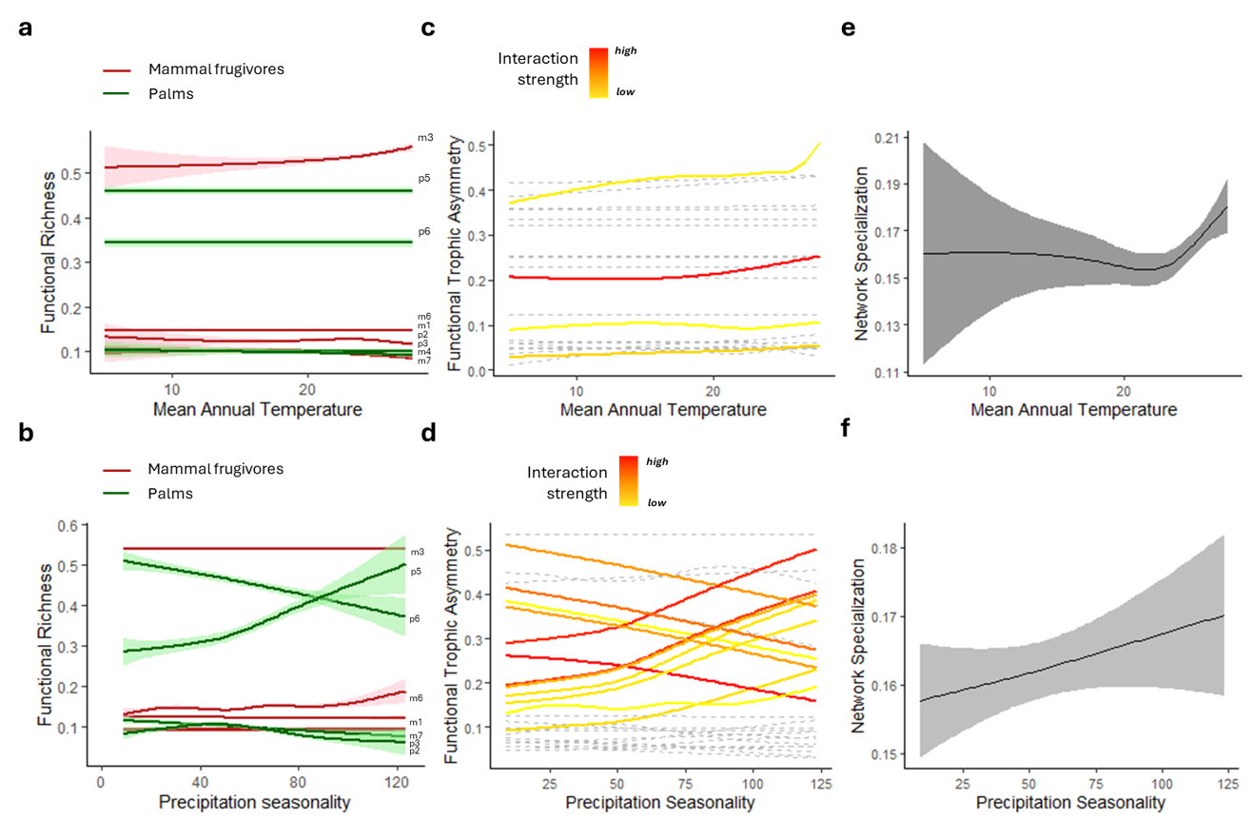

Relationships between environmental gradients, functional diversity, and network properties in the multitrophic system of mutualistic palm-mammal frugivore networks in Neotropics. (a, b) Trends in the functional richness of palms (green) and mammals (red) as a function of mean annual temperature (a) and precipitation seasonality (b), with shaded areas representing confidence intervals. Each trendline estimates the change in Functional Richness of an interaction guild. Each interaction guild corresponds to the species groupings found with the Stochastic Block Model and it is identified with labels at the higher end of the climatic gradient. (c, d) Functional trophic asymmetry (FTA) across temperature (c) and precipitation seasonality (d) for all combinations of potential interactions among and within guilds. Interaction strength indicated by a color gradient from yellow (low) to red (high). Trendlines for interaction guild combinations which are significantly affected with the changes in the climatic gradient are colored and shown in continuous lines. Trendlines for interaction guild combinations which are not responsive to climate are shown in gray and stippled lines. (e, f) Network specialization (z-score) along gradients of mean annual temperature (e) and precipitation seasonality (f), with shaded areas denoting confidence intervals. Network specialization is measured with the specialization index (H’), rarefied to be measured in networks of the same number of interactions, and z-score standardized for networks across sites by using a null model that simulates stochastic multispecies assembly.

### 3.4 Does interaction strength mediates the influence of climate on FTA?

The strength of interaction between guilds of consumers and producers had an overall positive effect on FTA ( Figure S6). FTA values showed a bi-modal distribution with peaks at high and low ends of the interaction strength spectrum (Figure S6). However, we did not find strong evidence supporting that the relationship between FTA and climate depends on the strength of interaction between interaction guilds (F = 746, P > 0.05). The interaction term between guild interaction strength and precipitation seasonality had a marginally significant, and positive, effect on FTA. (F = 0.14, P = 0.051) (Table 1). Assessing the relationship between FTA’ and H2’ We found that palm-mammalian frugivore networks have moderate levels of trophic specialization (H2’) ranging from 0.12 to 0.25, where 0 means species have no preference or specialization in their interaction partners and 1 represents networks where each species interacts only with a specific subset of interaction partners (Figure S7).

Geographic variation in H2’ positively relates to variation in FTA’ (F = 24.36; P < 0.001) (Figure 6c, 6d). H2’ also positively relates to the mean annual temperature of the atmosphere (F = 2.12, P = 0.03), however, effect uncertainty is stronger in cold regions than in warm regions (Figure 5e). Similarly, H2’ is positively related to precipitation seasonality PS (F = 2.29, P = 0.02). (Figure 5f) Finally, variation in H2’ does not relate to variation in temperature seasonality or total annual precipitation (both P > 0.05). The deviance explained by this model was 17.6%. (Table 2)

|  |  |  |  |  |  |  |  |  |  |  |  |  |  |  |  |  |  |  |  |  |  |  |  |  |  |  |  |  |  |  |  |  |  |  |  |  |  |  |  |  |
| --- | --- | --- | --- | --- | --- | --- | --- | --- | --- | --- | --- | --- | --- | --- | --- | --- | --- | --- | --- | --- | --- | --- | --- | --- | --- | --- | --- | --- | --- | --- | --- | --- | --- | --- | --- | --- | --- | --- | --- | --- |
| **Table 2**  Source: [Article Notebook](https://lessardlab.github.io/fta_ec_networks/index-preview.html)  Table 1: **Parametric coefficients**   |  | Estimate | Std. Error | t value | p-value | | --- | --- | --- | --- | --- | | Intercept | 0.16 | 0 | 86.33 | **<2e-16** |   Table 1: **Smooth Terms**   |  | edf | Ref.df | F | p-value | | --- | --- | --- | --- | --- | | FTA = s(sum_fta) | 5.97 | 7.18 | 24.37 | **<2e-16** | | Mean Annual Temperature = s(Temp) | 5.86 | 7.04 | 2.13 | **0.04** | | Precipitation seasonality = s(PS) | 5.42 | 6.56 | 2.29 | **0.03** | | Temperature seasonality = s(TS) | 1.00 | 1.00 | 0.74 | **0.39** | | Total Annual Precipitation = s(Prec) | 5.29 | 6.39 | 0.93 | **0.48** |   Source: [Article Notebook](https://lessardlab.github.io/fta_ec_networks/index-preview.html) |

## 4 Discussion

Our study reveals that producers and consumers differ in their functional responses to climatic gradient thereby giving rise to trophic asymmetry (FTA). The degree of FTA in palm-mammal frugivore assemblages varies across the Neotropics, with the highest value recorded in regions with a warm climate and a seasonal precipitation regime. Furthermore, species assemblages with high FTA also exhibited a high level of specialization in their trophic interaction networks. Taken together, our results suggest that distinct community assembly processes operate simultaneously across trophic levels, reinforcing the idea that network assembly emerges from a dynamic interplay of bottom-up and top-down processes (Moretti and Legg 2009; Marjakangas et al. 2022; Schleuning, Garcı́a, and Tobias 2023) which are context dependent.

Palms and mammal frugivore assemblages differ in their response to climatic gradients across the Neotropics. There is a positive relationship between the functional richness of mammal as-semblages and temperature, mainly driven by an increase in the richness of small-bodied, opportunistic mammal frugivores with broad diets (Figure 5a, Figure S1). Warm regions have high primary productivity, which translates into an abundance of fruits and other resources that sup-port a great diversity of mammal species and interaction traits (Losada, Suárez-Couselo, and Sobral 2024; Gorczynski et al. 2021). Among those, small tropical frugivores tend to have narrower climatic niches as they tend to be restricted to the warmest regions. As opposed to larger bodied mammals, they are less suited to cold climatic conditions because they more easily lose heat (Shipley and McGuire 2024). In addition, in warm regions, small frugivorous mammals invest less energy in thermoregulation and can allocate more energy to feeding and breeding (Merritt 2010; Arends and McNab 2001). Higher reproductive rates and shorter generation times over evolutionary time can create opportunities for adaptation or speciation (Allen et al. 2006). Finally, warm, and stable climates over evolutionary time could have lowered extinction rates, allowing these climatically sensitive small frugivore lineages to persist through time (Sandel et al. 2011).

The functional richness of palms does not relate to variation in temperature, but it is negatively related negatively related to precipitation seasonality. Palms, being megathermal plants, evolved in and require warm conditions year-round (Reichgelt, West, and Greenwood 2018; Eiserhardt et al. 2011). However, given the overall warm conditions of Neotropics, geographic variation in mean annual temperature exerts little constraints on palm functional richness. Studies show that variations in mean temperature within the tropical-subtropical range affect palm growth rates rather than community composition (Eiserhardt et al. 2011). Unlike temperature, annual precipitation seasonality strongly relates to palm functional richness. When precipitation becomes seasonal, the overall number of palms species tends to decline, and drought-tolerant palm types are more represented in palm assemblages (Eiserhardt et al. 2011; Sousa et al. 2020) (Figure 5b). As such these habitats favor species with water-saving strategies (e.g. large-nuts) over water-spending ones (e.g. fast growth and large leaves) (Emilio et al. 2019; Eiserhardt et al. 2011). In warm and wet habitats, both strategies coexist since water is abundant (Eiserhardt et al. 2011).

Functional Trophic Asymmetry (FTA) varied geographically, peaking in warm regions with highly seasonal precipitation (Figure 6). Overall, average annual temperature has a small but positive effect on FTA. This is mainly due to a proportionally greater representation of guilds with small generalist mammals frugivores in assemblages of warm regions relative to the functional richness of interacting palm assemblages. As such, variation in mean annual temperature and its effects on FTA were associated with shifts in the functional richness of mammals rather than shifts in the functional diversity of palms. These results support the view that the mode of assembly in palm-frugivore networks inhabiting the warmest regions of the neotropics is top-down (i.e. consumer-driven) (Dehling et al. 2016; Sonne et al. 2016; Albrecht et al. 2018; Marjakangas et al. 2022; Dehling, Barreto, and Graham 2022). In contrast, the significant influence of precipitation seasonality on the functional richness of palm assemblages supports the view that the mode of assembly in palm-frugivore networks inhabiting areas with highly seasonal precipitations is bottom-up (producer-driven).

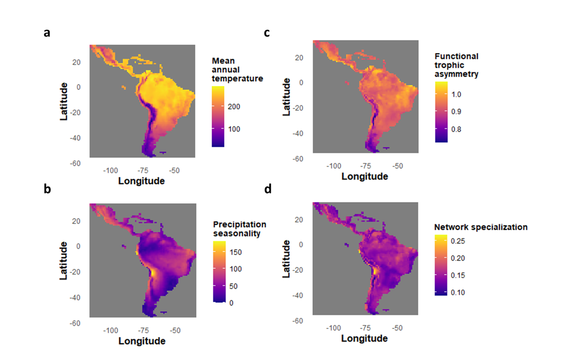

Spatial distribution of climate, functional trophic asymmetry, and network specialization for palm-mammal frugivore seed dispersal networks across the Neotropics. Panels (a) and (a) show the geographical variation in mean annual temperature and precipitation seasonality, respectively, with warmer colors indicating higher values. Panels (c) and (d) depict the spatial patterns of functional trophic asymmetry (FTA) and network specialization (H2’), where higher values are also represented by warmer colors. FTA (Panel c) reflects variation in functional trophic asymmetry across regions, with higher values concentrated in areas of higher temperature and seasonality. Network specialization (Panel d) indicates the degree of exclusive interactions within ecological networks. Color scales for each map are shown in adjacent legends.

Interaction strength, representing the intensity of the effect that one species has on another within an ecological network, varies significantly across palms and mammal frugivore guilds. Moreover, variation in the strength of interaction between palm-frugivore guilds mediates the response of FTA to precipitation seasonality. Specifically, strongly interacting guilds show a more significant and positive relationship between FTA and precipitation seasonality. In other words, palm species among guilds with more specialized seed dispersal are more common while palm species among guilds with a generalist seed dispersal strategy become rarer towards regions where rainfall is seasonal (Figure 5b, 5d). As precipitation becomes more seasonal, palm functional richness shifts towards large-fruited species and mammal frugivore generalists become scarcer. Our results align with findings such as from bat-plant mutualistic pollination networks, where interacting species exhibit lower niche overlap in highly seasonal environments, and for avian-frugivory networks where weaker trait matching is found towards the tropics (Schleuning et al. 2012; Huang, Dalsgaard, and Chen 2025), but also contrast with others that report stronger trait-matching and interaction strength towards the tropics in plant-hummingbird pollination networks (Sonne et al. 2020) and avian-palm frugivory (McFadden et al. 2022).

The concept of functional trophic asymmetry (FTA) offers a valuable framework to examine how multitrophic ecological communities respond to shifting environmental conditions. Our results suggest that as global climate change accelerates, rising temperatures and altered precipitation regimes are likely to increase FTA multitrophic palm-frugivore communities and increase specialization in palm seed dispersal networks. A likely consequence is also the loss of ecosystem function, namely plant functional connectivity —the dispersal of plant propagules between habitat patches—, which has been shown to decrease with increased specialization and reduced plant functional diversity (Landim et al. 2025). The same could be true of other ecosystem functions in other types of mutualistic networks, but it remains to be explored (Landim et al. 2025; Rabeau et al. 2025; Acosta-Rojas et al. 2023; Nowak et al. 2025). In addition to climate change, habitat fragmentation and human-induced landscape modifications can independently alter resource and consumer functional diversity, thereby affecting FTA (Guevara et al., n.d.; Béllo Carvalho, Malhi, and Oliveras Menor 2023). Although differences in the extent of landscape fragmentation were not directly investigated in this study, previous research shows that deforestation has a greater impact on the diversity and redundancy of functional roles in plants than in their hummingbird pollinators, suggesting a decline in plant functional roles as forests are lost. Such results reinforce the role of FTA as a key indicator in predicting shifts in ecosystem function (Montoya and Raffaelli 2010; Bello, Schleuning, and Graham 2023; Brodie, Williams, and Garner 2021)as species distributions shift in response to climate change (Aizen, Sabatino, and Tylianakis 2012; Valiente-Banuet et al. 2015; Bartley et al. 2019; Hurtado et al. 2024). Adding additional information such as geographical variation in population density, land-use change, or spatial movement data (e.g., GPS tracking of frugivores) would improve realism and generalization of our models (Borah, Solanki, and Bhattacharjee 2022; Cousens et al. 2010; Beumer et al. 2025). Future work can integrate these elements into our data pipelines once the relevant data becomes available.

## 5 Supplementary material:

### 5.1 Supplementary figures

### Figure S1

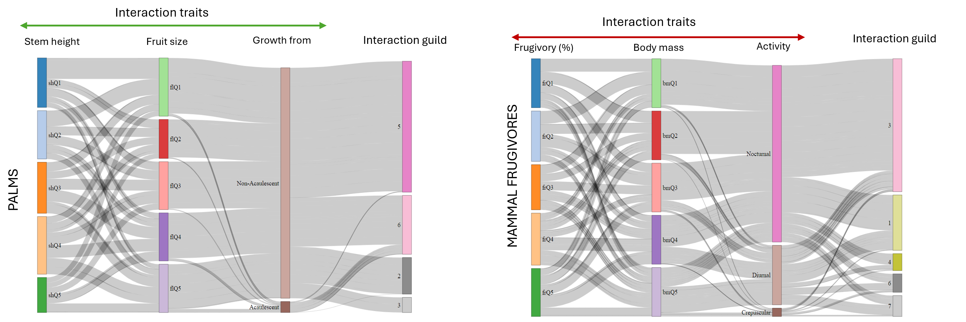

Sankey diagrams illustrating the differences in trait associations to an interaction guild across trophic levels. Top panel - palms: Relationships between stem height and fruit size, followed by a growth form classification (Aculescent vs. Non-Aculescent). Bottom panel-mammal frugivores: Relationships between percentage frugivory in diet and body size categorized into different activity periods (Nocturnal, Diurnal, and Crepuscular). Stem height, Fruit size, Frugivory (%) and Body mass are continuous traits that are grouped into quintiles for visualization purposes. Interaction guilds are defined for both groups with Stochastic Block Modelling of the palm-mammal frugivore interaction aggregated metaweb for the Neotropics. Trait associations to interaction guilds were discovered through multinomial classification modelling using a neural network backend.

### Figure S2

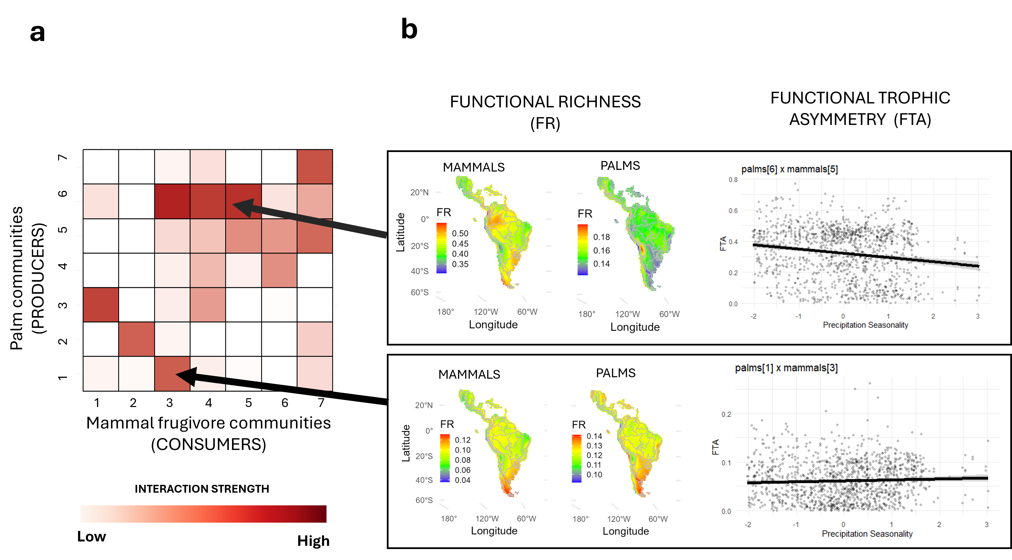

### Figure S3

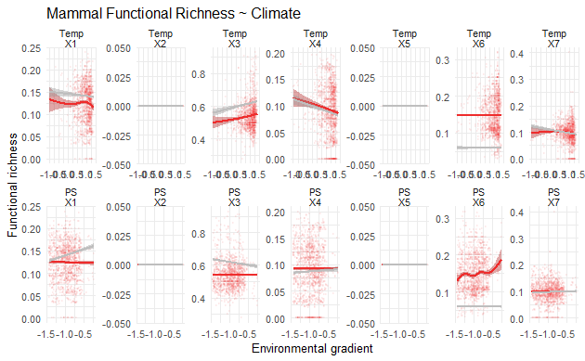

Changes in the functional richness of mammals along gradients of temperature and precipitation seasonality. Each pane represents the trend of the communities of mammals in a single interaction guild. Red lines represent observed trends, gray lines represent expected trends from a null model

### Figure S4

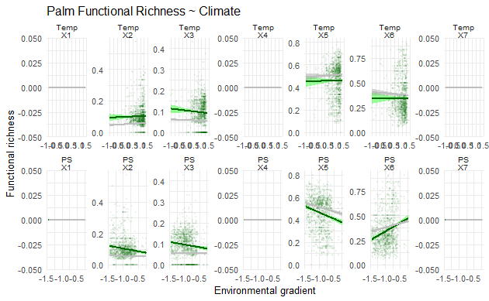

Changes in the functional richness of palms along gradients of temperature and precipitation seasonality. Each pane represents the trend of the communities of mammals in a single interaction guild. Green lines represent observed trends, gray lines represent expected trends from a null model.

### Figure S5

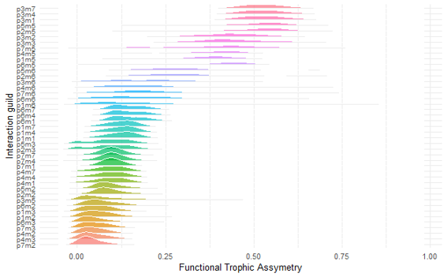

Functional trophic asymmetry across interaction guilds. Histograms show the distribution of FTA across each combination of palm (p) and mammal (m) guilds across the Neotropics.

### Figure S6

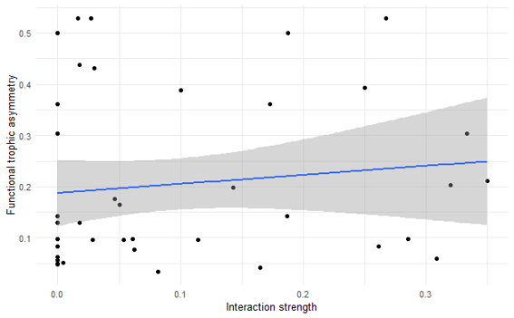

The relationship between Functional Trophic Asymmetry and Interaction Strength. The y-axis represents the median FTA of an interaction guild. The x-axis represents the interaction strength, measured by their interaction probability between guilds modelled by a stochastic block model (SBM)

### Figure S7

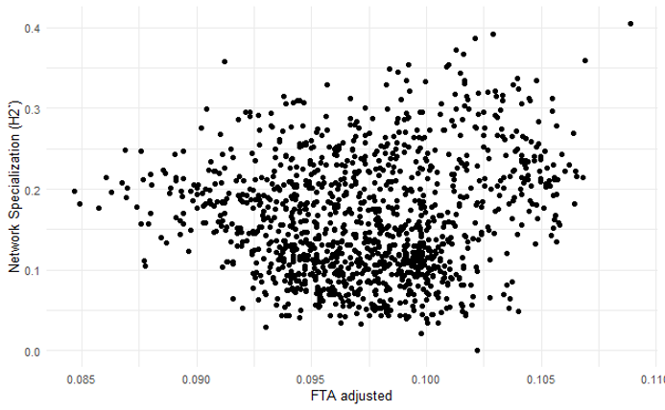

The relationship between Network specialization and FTA (adjusted for interaction strength)

### Figure S8

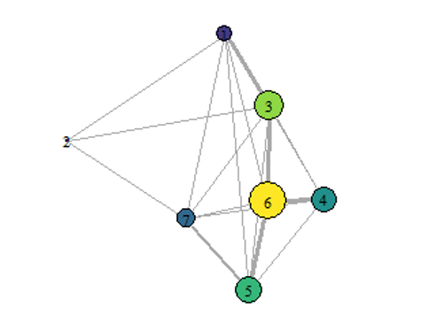

The relative influence of distinct nteraction guilds on mantaining the strupalm-seed dispersal networks in the structure Neotropics. Nodes represent a consumer/producer guild and links represents interactions among them. The size of nodes highlights the node-centrality, a measure of connectivity and influence over other nodes in the network.

## 6 Supplementary tables

## 7 Supplementary text

Acevedo-Quintero, Juan Fernando, Joan Gastón Zamora-Abrego, and Daniel Garcı́a. 2020. “From Structure to Function in Mutualistic Interaction Networks: Topologically Important Frugivores Have Greater Potential as Seed Dispersers.” *Journal of Animal Ecology* 89 (9): 2181–91.

Ackerly, David D. 2003. “Community Assembly, Niche Conservatism, and Adaptive Evolution in Changing Environments.” *International Journal of Plant Sciences* 164 (S3): S165–84.

Acosta-Rojas, Diana Carolina, Maciej K Barczyk, Carlos Iván Espinosa, Nina Farwig, Jürgen Homeier, Yvonne Tiede, Boris A Tinoco, et al. 2023. “Abiotic Factors Similarly Shape the Distribution of Fruit, Seed and Leaf Traits in Tropical Fleshy-Fruited Tree Communities.” *Acta Oecologica* 121: 103953.

Aizen, Marcelo A, Malena Sabatino, and Jason M Tylianakis. 2012. “Specialization and Rarity Predict Nonrandom Loss of Interactions from Mutualist Networks.” *Science* 335 (6075): 1486–89.

Albrecht, Jörg, Alice Classen, Maximilian GR Vollstädt, Antonia Mayr, Neduvoto P Mollel, David Schellenberger Costa, Hamadi I Dulle, et al. 2018. “Plant and Animal Functional Diversity Drive Mutualistic Network Assembly Across an Elevational Gradient.” *Nature Communications* 9 (1): 3177.

Allen, Craig R, AS Garmestani, TD Havlicek, Pablo A Marquet, GD Peterson, C Restrepo, CA Stow, and BE Weeks. 2006. “Patterns in Body Mass Distributions: Sifting Among Alternative Hypotheses.” *Ecology Letters* 9 (5): 630–43.

Allesina, Stefano, David Alonso, and Mercedes Pascual. 2008. “A General Model for Food Web Structure.” *Science* 320 (5876): 658–61.

Arends, Alexis, and Brian K McNab. 2001. “The Comparative Energetics of ‘Caviomorph’rodents.” *Comparative Biochemistry and Physiology Part A: Molecular & Integrative Physiology* 130 (1): 105–22.

Bartley, Timothy J, Kevin S McCann, Carling Bieg, Kevin Cazelles, Monica Granados, Matthew M Guzzo, Andrew S MacDougall, Tyler D Tunney, and Bailey C McMeans. 2019. “Food Web Rewiring in a Changing World.” *Nature Ecology & Evolution* 3 (3): 345–54.

Bello, Carolina, Matthias Schleuning, and Catherine H Graham. 2023. “Analyzing Trophic Ecosystem Functions with the Interaction Functional Space.” *Trends in Ecology & Evolution* 38 (5): 424–34.

Béllo Carvalho, Rodrigo, Yadvinder Malhi, and Imma Oliveras Menor. 2023. “Frugivory and Seed Dispersal in the Cerrado: Network Structure and Defaunation Effects.” *Biotropica* 55 (4): 849–65.

Beumer, Larissa T, Anne Gabriela Hertel, Raphael Royaute, Marlee A Tucker, Joerg Albrecht, Roxanne Beltran, Francesca Cagnacci, et al. 2025. “MoveTraits-a Database for Integrating Animal Behaviour into Trait-Based Ecology.” *bioRxiv*, 2025–03.

Bjorholm, Stine, Jens-Christian Svenning, Flemming Skov, and Henrik Balslev. 2005. “Environmental and Spatial Controls of Palm (Arecaceae) Species Richness Across the Americas.” *Global Ecology and Biogeography* 14 (5): 423–29.

Blüthgen, Nico, and Alexandra-Maria Klein. 2011. “Functional Complementarity and Specialisation: The Role of Biodiversity in Plant–Pollinator Interactions.” *Basic and Applied Ecology* 12 (4): 282–91.

Blüthgen, Nico, Florian Menzel, and Nils Blüthgen. 2006. “Measuring Specialization in Species Interaction Networks.” *BMC Ecology* 6: 1–12.

Blüthgen, Nico, Florian Menzel, Thomas Hovestadt, Brigitte Fiala, and Nils Blüthgen. 2007. “Specialization, Constraints, and Conflicting Interests in Mutualistic Networks.” *Current Biology* 17 (4): 341–46.

Bogoni, Juliano A, Carlos A Peres, and Katia MPMB Ferraz. 2020. “Extent, Intensity and Drivers of Mammal Defaunation: A Continental-Scale Analysis Across the Neotropics.” *Scientific Reports* 10 (1): 14750.

Borah, Dhiraj Kumar, GhanShyam Solanki, and Parimal Ch Bhattacharjee. 2022. “Seasonal Variations in Home Range Size of Capped Langur (Trachypithecus Pileatus) in a Degraded Habitat in Assam, India.” *Ecological Questions* 33 (3): 59–66.

Brodie, Jedediah F, Sara Williams, and Brittany Garner. 2021. “The Decline of Mammal Functional and Evolutionary Diversity Worldwide.” *Proceedings of the National Academy of Sciences* 118 (3): e1921849118.

Cousens, Roger D, Julian Hill, Kris French, and Ian D Bishop. 2010. “Towards Better Prediction of Seed Dispersal by Animals.” *Functional Ecology* 24 (6): 1163–70.

Dehling, D Matthias, Elisa Barreto, and Catherine H Graham. 2022. “The Contribution of Mutualistic Interactions to Functional and Phylogenetic Diversity.” *Trends in Ecology & Evolution* 37 (9): 768–76.

Dehling, D Matthias, Irene MA Bender, Pedro G Blendinger, Katrin Böhning-Gaese, Marcia C Muñoz, Eike L Neuschulz, Marta Quitián, et al. 2021. “Specialists and Generalists Fulfil Important and Complementary Functional Roles in Ecological Processes.” *Functional Ecology* 35 (8): 1810–21.

Dehling, D Matthias, Pedro Jordano, H Martin Schaefer, Katrin Böhning-Gaese, and Matthias Schleuning. 2016. “Morphology Predicts Species’ Functional Roles and Their Degree of Specialization in Plant–Frugivore Interactions.” *Proceedings of the Royal Society B: Biological Sciences* 283 (1823): 20152444.

Donoso, Isabel, Matthias Schleuning, Daniel Garcı́a, and Jochen Fründ. 2017. “Defaunation Effects on Plant Recruitment Depend on Size Matching and Size Trade-Offs in Seed-Dispersal Networks.” *Proceedings of the Royal Society B: Biological Sciences* 284 (1855): 20162664.

Donoso, Isabel, Marjorie C Sorensen, Pedro G Blendinger, W Daniel Kissling, Eike Lena Neuschulz, Thomas Mueller, and Matthias Schleuning. 2020. “Downsizing of Animal Communities Triggers Stronger Functional Than Structural Decay in Seed-Dispersal Networks.” *Nature Communications* 11 (1): 1582.

Eiserhardt, Wolf L, Jens-Christian Svenning, W Daniel Kissling, and Henrik Balslev. 2011. “Geographical Ecology of the Palms (Arecaceae): Determinants of Diversity and Distributions Across Spatial Scales.” *Annals of Botany* 108 (8): 1391–1416.

Emer, Carine, and Jane Memmott. 2023. “Intraspecific Variation of Invaded Pollination Networks–the Role of Pollen-Transport, Pollen-Transfer and Different Levels of Biological Organization.” *Perspectives in Ecology and Conservation* 21 (2): 151–63.

Emilio, Thaise, Laurent J Lamarque, José M Torres-Ruiz, Andrew King, Guillaume Charrier, Régis Burlett, Maria Conejero, Paula J Rudall, William J Baker, and Sylvain Delzon. 2019. “Embolism Resistance in Petioles and Leaflets of Palms.” *Annals of Botany* 124 (7): 1173–83.

Fick, Stephen E, and Robert J Hijmans. 2017. “WorldClim 2: New 1-Km Spatial Resolution Climate Surfaces for Global Land Areas.” *International Journal of Climatology* 37 (12): 4302–15.

Garcı́a, Daniel, Isabel Donoso, and Javier Rodrı́guez-Pérez. 2018. “Frugivore Biodiversity and Complementarity in Interaction Networks Enhance Landscape-Scale Seed Dispersal Function.” *Functional Ecology* 32 (12): 2742–52.

Gevrey, Muriel, Ioannis Dimopoulos, and Sovan Lek. 2003. “Review and Comparison of Methods to Study the Contribution of Variables in Artificial Neural Network Models.” *Ecological Modelling* 160 (3): 249–64.

Gorczynski, Daniel, Chia Hsieh, Jadelys Tonos Luciano, Jorge Ahumada, Santiago Espinosa, Steig Johnson, Francesco Rovero, et al. 2021. “Tropical Mammal Functional Diversity Increases with Productivity but Decreases with Anthropogenic Disturbance.” *Proceedings of the Royal Society B* 288 (1945): 20202098.

Guevara, Esteban, François Duchenne, Tatiana Santander, and Catherine H Graham. n.d. “Land Use Change Affects the Contribution of Niche-Based Processes to Plant-Pollinator Interactions, with Possible Consequences for Network Structure.” *Available at SSRN 4907880*.

Halpern, Benjamin S, and Sergio R Floeter. 2008. “Functional Diversity Responses to Changing Species Richness in Reef Fish Communities.” *Marine Ecology Progress Series* 364: 147–56.

HilleRisLambers, Janneke, Peter B Adler, W Stanley Harpole, Jonathan M Levine, and Margaret M Mayfield. 2012. “Rethinking Community Assembly Through the Lens of Coexistence Theory.” *Annual Review of Ecology, Evolution, and Systematics* 43 (1): 227–48.

Hoekstra, Folkert A, Elena A Golovina, and Julia Buitink. 2001. “Mechanisms of Plant Desiccation Tolerance.” *Trends in Plant Science* 6 (9): 431–38.

Holt, Ben G, Gabriel C Costa, Caterina Penone, Jean-Philippe Lessard, Thomas M Brooks, Ana D Davidson, S Blair Hedges, et al. 2018. “Environmental Variation Is a Major Predictor of Global Trait Turnover in Mammals.” *Journal of Biogeography* 45 (1): 225–37.

Huang, Xiao, Bo Dalsgaard, and Si-Chong Chen. 2025. “Weaker Plant-Frugivore Trait Matching Towards the Tropics and on Islands.” *Ecology Letters* 28 (1): e70061.

Hurtado, Pilar, Gregorio Aragón, Marina Vicente, Bo Dalsgaard, Boris R Krasnov, and Joaquı́n Calatayud. 2024. “Generalism in Species Interactions Is More the Consequence Than the Cause of Ecological Success.” *Nature Ecology & Evolution* 8 (9): 1602–11.

Kissling, W Daniel, Henrik Balslev, William J Baker, John Dransfield, Bastian Göldel, Jun Ying Lim, Renske E Onstein, and Jens-Christian Svenning. 2019. “PalmTraits 1.0, a Species-Level Functional Trait Database of Palms Worldwide.” *Scientific Data* 6 (1): 178.

Kissling, W Daniel, Carsten F Dormann, Jürgen Groeneveld, Thomas Hickler, Ingolf Kühn, Greg J McInerny, José M Montoya, et al. 2012. “Towards Novel Approaches to Modelling Biotic Interactions in Multispecies Assemblages at Large Spatial Extents.” *Journal of Biogeography* 39 (12): 2163–78.

Kraft, Nathan JB, and David D Ackerly. 2010. “Functional Trait and Phylogenetic Tests of Community Assembly Across Spatial Scales in an Amazonian Forest.” *Ecological Monographs* 80 (3): 401–22.

Kraft, Nathan JB, Peter B Adler, Oscar Godoy, Emily C James, Steve Fuller, and Jonathan M Levine. 2015. “Community Assembly, Coexistence and the Environmental Filtering Metaphor.” *Functional Ecology* 29 (5): 592–99.

Kraft, Nathan JB, Renato Valencia, and David D Ackerly. 2008. “Functional Traits and Niche-Based Tree Community Assembly in an Amazonian Forest.” *Science* 322 (5901): 580–82.

Laliberté, Etienne, and Pierre Legendre. 2010. “A Distance-Based Framework for Measuring Functional Diversity from Multiple Traits.” *Ecology* 91 (1): 299–305.

Landim, Anna R, Eike Lena Neuschulz, Isabel Donoso, Marjorie C Sorensen, Thomas Mueller, and Matthias Schleuning. 2025. “Functional Connectivity of Animal-Dispersed Plant Communities Depends on the Interacting Effects of Network Specialization and Resource Diversity.” *Proceedings B* 292 (2042): 20242995.

Lavorel, Sandra. 2013. “Plant Functional Effects on Ecosystem Services.” *Journal of Ecology*. Wiley Online Library.

Losada, Marı́a, Miguel Suárez-Couselo, and Mar Sobral. 2024. “Geographic Distribution of Mammal Diets.” *Web Ecology* 24 (2): 71–79.

Marjakangas, Emma-Liina, Gabriel Muñoz, Shaun Turney, Jörg Albrecht, Eike Lena Neuschulz, Matthias Schleuning, and Jean-Philippe Lessard. 2022. “Trait-Based Inference of Ecological Network Assembly: A Conceptual Framework and Methodological Toolbox.” *Ecological Monographs* 92 (2): e1502.

Marques Dracxler, Caroline, and W Daniel Kissling. 2022. “The Mutualism–Antagonism Continuum in Neotropical Palm–Frugivore Interactions: From Interaction Outcomes to Ecosystem Dynamics.” *Biological Reviews* 97 (2): 527–53.

McCain, Christy M, and Sarah RB King. 2014. “Body Size and Activity Times Mediate Mammalian Responses to Climate Change.” *Global Change Biology* 20 (6): 1760–69.

McFadden, Ian R, Susanne A Fritz, Niklaus E Zimmermann, Loı̈c Pellissier, W Daniel Kissling, Joseph A Tobias, Matthias Schleuning, and Catherine H Graham. 2022. “Global Plant-Frugivore Trait Matching Is Shaped by Climate and Biogeographic History.” *Ecology Letters* 25 (3): 686–96.

Merritt, Joseph F. 2010. *The Biology of Small Mammals*. JHU Press.

Messeder, João Vitor S, Fernando AO Silveira, Tatiana G Cornelissen, Lisieux F Fuzessy, and Tadeu J Guerra. 2021. “Frugivory and Seed Dispersal in a Hyperdiverse Plant Clade and Its Role as a Keystone Resource for the Neotropical Fauna.” *Annals of Botany* 127 (5): 577–95.

Montoya, José M, and Dave Raffaelli. 2010. “Climate Change, Biotic Interactions and Ecosystem Services.” *Philosophical Transactions of the Royal Society B: Biological Sciences* 365 (1549): 2013–18.

Moretti, Marco, and Colin Legg. 2009. “Combining Plant and Animal Traits to Assess Community Functional Responses to Disturbance.” *Ecography* 32 (2): 299–309.

Muñoz, Gabriel, Kristian Trøjelsgaard, and W Daniel Kissling. 2019. “A Synthesis of Animal-Mediated Seed Dispersal of Palms Reveals Distinct Biogeographical Differences in Species Interactions.” *Journal of Biogeography* 46 (2): 466–84.

Nowak, Larissa, Evan C Fricke, Anna Traveset, and Isabel Donoso. 2025. “Impacts of Species Introductions on the Trait Diversity of Interacting Avian Frugivores and Fleshy-Fruited Plants Depend on Native Trait Diversity.” *bioRxiv*, 2025–01.

Onstein, Renske E, William J Baker, Thomas LP Couvreur, Søren Faurby, Jens-Christian Svenning, and W Daniel Kissling. 2017. “Frugivory-Related Traits Promote Speciation of Tropical Palms.” *Nature Ecology & Evolution* 1 (12): 1903–11.

Onstein, Renske E, Richard J Carter, Yaowu Xing, and H Peter Linder. 2014. “Diversification Rate Shifts in the Cape Floristic Region: The Right Traits in the Right Place at the Right Time.” *Perspectives in Plant Ecology, Evolution and Systematics* 16 (6): 331–40.

Paine, CE Timothy, Christopher Baraloto, Jérôme Chave, and Bruno Hérault. 2011. “Functional Traits of Individual Trees Reveal Ecological Constraints on Community Assembly in Tropical Rain Forests.” *Oikos* 120 (5): 720–27.

Poisot, Timothée. 2023. “Guidelines for the Prediction of Species Interactions Through Binary Classification.” *Methods in Ecology and Evolution* 14 (5): 1333–45.

Rabeau, Alexandre, Alexander Pigot, Joseph Tobias, and Matthias Schleuning. 2025. “Projected Impacts of Climate Change on Plant-Frugivore Interactions Across the Americas.” *bioRxiv*, 2025–03.

Reichgelt, Tammo, Christopher K West, and David R Greenwood. 2018. “The Relation Between Global Palm Distribution and Climate.” *Scientific Reports* 8 (1): 4721.

Rohr, Rudolf Philippe, Heike Scherer, Patrik Kehrli, Christian Mazza, and Louis-Félix Bersier. 2010. “Modeling Food Webs: Exploring Unexplained Structure Using Latent Traits.” *The American Naturalist* 176 (2): 170–77.

Sandel, Brody, L Arge, Bo Dalsgaard, RG Davies, KJ Gaston, WJ Sutherland, and J-C Svenning. 2011. “The Influence of Late Quaternary Climate-Change Velocity on Species Endemism.” *Science* 334 (6056): 660–64.

Saravia, Leonardo A, Tomás I Marina, Nadiah P Kristensen, Marleen De Troch, and Fernando R Momo. 2022. “Ecological Network Assembly: How the Regional Metaweb Influences Local Food Webs.” *Journal of Animal Ecology* 91 (3): 630–42.

Schleuning, Matthias, Jochen Fründ, Alexandra-Maria Klein, Stefan Abrahamczyk, Ruben Alarcón, Matthias Albrecht, Georg KS Andersson, et al. 2012. “Specialization of Mutualistic Interaction Networks Decreases Toward Tropical Latitudes.” *Current Biology* 22 (20): 1925–31.

Schleuning, Matthias, Daniel Garcı́a, and Joseph A Tobias. 2023. “Animal Functional Traits: Towards a Trait-Based Ecology for Whole Ecosystems.” *Functional Ecology*. Wiley Online Library.

Seibold, Sebastian, Marc W Cadotte, J Scott MacIvor, Simon Thorn, and Jörg Müller. 2018. “The Necessity of Multitrophic Approaches in Community Ecology.” *Trends in Ecology & Evolution* 33 (10): 754–64.

Shipley, Benjamin R, and Jenny L McGuire. 2024. “The Environmental Conditions of Endemism Hotspots Shape the Functional Traits of Mammalian Assemblages.” *Proceedings of the Royal Society B* 291 (2018): 20232773.

Sonne, Jesper, Ana M Martı́n González, Pietro K Maruyama, Brody Sandel, Jeferson Vizentin-Bugoni, Matthias Schleuning, Stefan Abrahamczyk, et al. 2016. “High Proportion of Smaller Ranged Hummingbird Species Coincides with Ecological Specialization Across the Americas.” *Proceedings of the Royal Society B: Biological Sciences* 283 (1824): 20152512.

Sonne, Jesper, Jeferson Vizentin-Bugoni, Pietro K Maruyama, Andréa C Araujo, Edgar Chávez-González, Aline G Coelho, Peter A Cotton, et al. 2020. “Ecological Mechanisms Explaining Interactions Within Plant–Hummingbird Networks: Morphological Matching Increases Towards Lower Latitudes.” *Proceedings of the Royal Society B* 287 (1922): 20192873.

Sousa, Thaiane R, Juliana Schietti, Fernanda Coelho de Souza, Adriane Esquivel-Muelbert, Igor O Ribeiro, Thaise Emı́lio, Pedro ACL Pequeno, Oliver Phillips, and Flavia RC Costa. 2020. “Palms and Trees Resist Extreme Drought in Amazon Forests with Shallow Water Tables.” *Journal of Ecology* 108 (5): 2070–82.

Strydom, Adéle, Juanita Mellet, Jeanne Van Rensburg, Ignatius Viljoen, Anastasios Athanasiadis, and Michael S Pepper. 2022. “Open Access and Its Potential Impact on Public Health–a South African Perspective.” *Frontiers in Research Metrics and Analytics* 7: 975109.

Terry, J Christopher D, and Owen T Lewis. 2020. “Finding Missing Links in Interaction Networks.” *Ecology* 101 (7): e03047.

Valiente-Banuet, Alfonso, Marcelo A Aizen, Julio M Alcántara, Juan Arroyo, Andrea Cocucci, Mauro Galetti, Marı́a B Garcı́a, et al. 2015. “Beyond Species Loss: The Extinction of Ecological Interactions in a Changing World.” *Functional Ecology* 29 (3): 299–307.

Villéger, Sébastien, Norman WH Mason, and David Mouillot. 2008. “New Multidimensional Functional Diversity Indices for a Multifaceted Framework in Functional Ecology.” *Ecology* 89 (8): 2290–2301.

Wilman, Hamish, Jonathan Belmaker, Jennifer Simpson, Carolina de la Rosa, Marcelo M Rivadeneira, and Walter Jetz. 2014. “EltonTraits 1.0: Species-Level Foraging Attributes of the World’s Birds and Mammals: Ecological Archives E095-178.” *Ecology* 95 (7): 2027–27.

Wood, Simon. 2017. “Mgcv-Package Mixed GAM Computation Vehicle with GCV/AIC/REML Smoothness Estimation and GAMMs by REML/PQL.” *Docs. W3cub. Com*.